Fusing together organic texture with chalkier colours has led to the development of Forbo Flooring Systems new contemporary, high-end carpet tile collection: Tessera Chroma. The carefully composed colourways, which offer a colour balance when combined, allow you to playfully clash shades to create more dynamic and diverse workspaces.

Chroma is the quality by which we communicate colour; it’s how we define a colour’s purity, intensity or saturation. It also provides a measure of how we can fuse relationships between colours to bring balance and harmony to a space and Forbo’s Tessera Chroma collection has been created with this in mind.

Jason Holmes, Head of Textile Design at Forbo Flooring Systems, commented: “There is a new, more sophisticated trend emerging onto the workspace design scene, where we see schemes morphing into leisure and hospitality inspired spaces characterised by carefully curated colours and the introduction of iconic accessories.”

Comprising 12 neutral and 15 bright colours, Tessera Chroma’s palette has been selected to have a subtle blended effect, thanks to each colourway consisting of three different shades. This has helped to provide a warm aesthetic and allow specifiers to create eclectic colour combinations that can bring out the desired personality of spaces.

Jason continues: “While at the same time, we are also seeing softer, organic patterns and textures emerging, which are enhanced by a greater focus on warmer greys, cooler neutrals and colours based on natural materials and environments, giving a nod to the continuing nature inspired trend across all industry sectors.”

The fresh colours found within the collection can be used as a more understated way of bringing the outside in and as such, specifiers will discover five modern hues of green within this collection to work perfectly with the biophilic interior design.

Forbo is committed to creating better environments and as such, Tessera Chroma contains 62% recycled content, is manufactured using 100% renewable energy and meets the Ska rating for M12 soft floor coverings.

For more information please visit www.forbo-flooring.co.uk/tesserachroma

-ENDS-

Image | Information
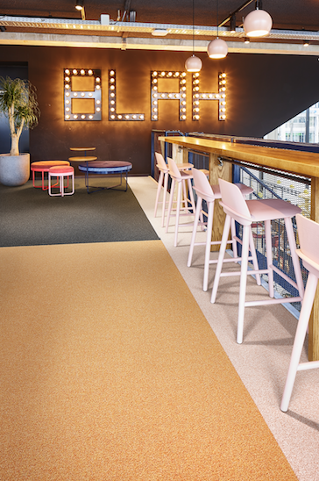 | Tessera Chroma in 3621 | camisole, 3623 | tangerine and 3606 | tuxedo
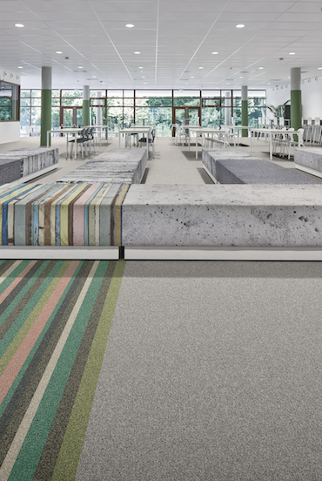 | Tessera Chroma in 3616 | eucalyptus, 3617 | botanical, 3621 | camisole, 3618 | torrent, 3607 | mineral, 3609 | coconut and 3601 | platinum
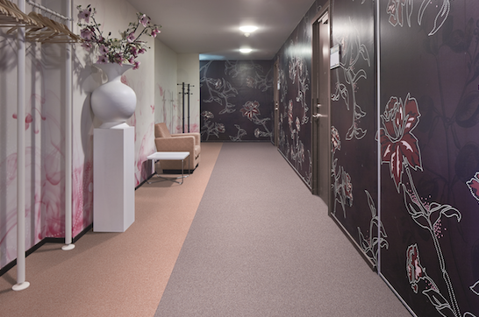 | Tessera Chroma in 3622 | wisteria and 3621 | camisole
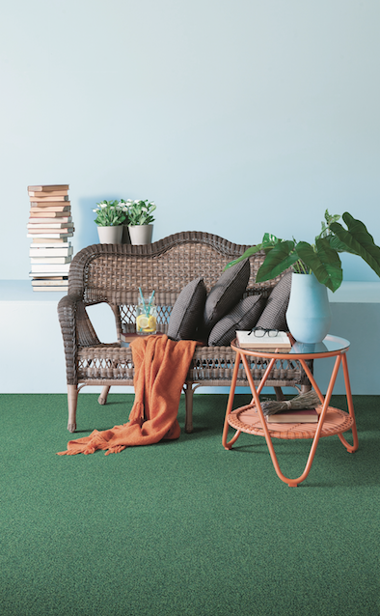 | Tessera Chroma in 3620 | evergreen
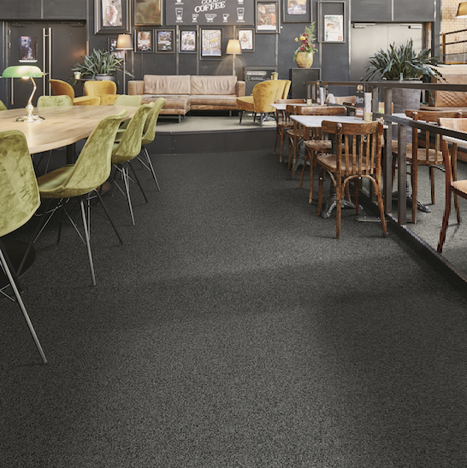 | Tessera Chroma in 3607 | mineral, 3609 | coconut and 3601 | platinum

